Online Meeting Assistant

Microsoft 365 License Prerequisites
- Microsoft 365 Business license with SharePoint
- Power App Premium license – includes 500 AI Builder credits per user per month (bare minimum, one workflow run to process a 1-hour meeting may consume 60-120 AI credits)
- (optional) Power Automate Premium license – includes premium connectors and 5000 AI Builder credits per user per month
- (optional) pay-as-you-go AI Builder licenses or bundles.
- AI credits need to be assigned to the environment, where you run you Power Automate solution.

SharePoint Prerequisites (Mandatory)
- You must have access to a SharePoint Online site where you have at least Edit permissions.
- All required folders must exist before the flow is run.
The following components must be created manually in SharePoint before first use:
- A document library (normally ‘Shared Documents’) – NO NEED TO CREATE IT.
- A folder for meeting transcripts (Shared Documents/Meeting transcripts)
- A folder for generated meeting minutes (e.g. ‘Shared Documents/Meeting Minutes`).
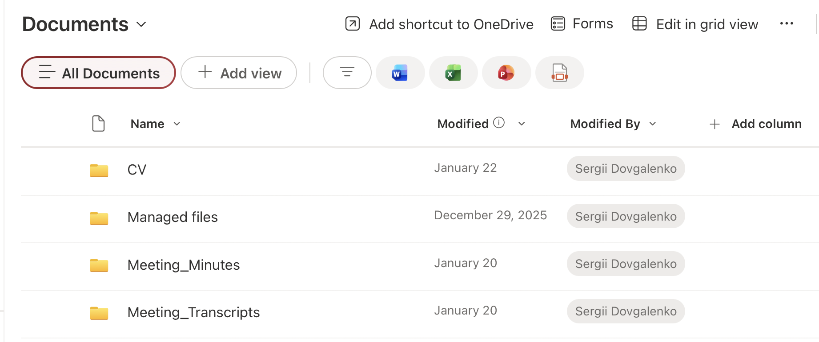

- a SharePoint List containing meeting members. The flow will automatically send the output (minutes and action points) to the members from this list. It only contains one two columns - Title which we renamed ‘Member’, and Email (Text). Note the list name, once you decided how to call it. 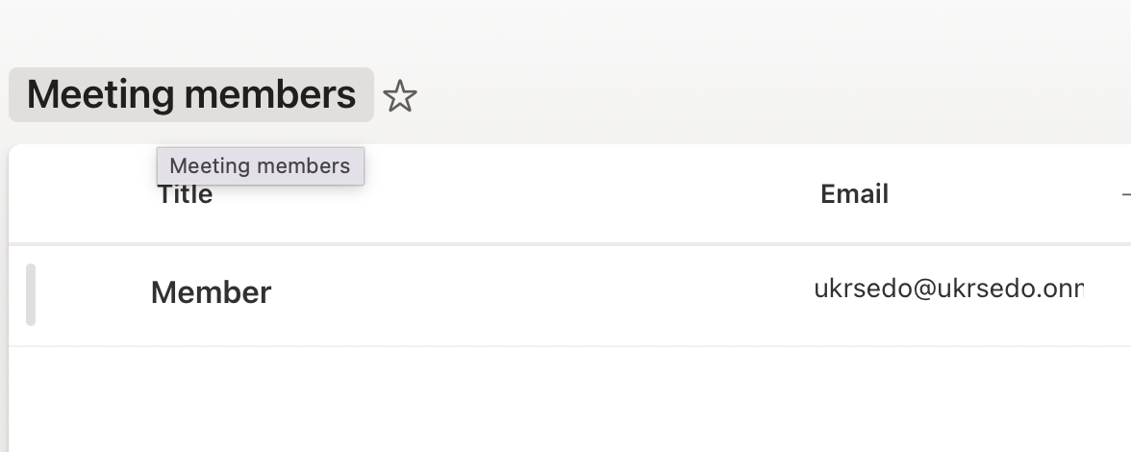

⚠️ Important: If the transcript or minutes folder does not exist, the flow will fail at runtime with a SharePoint error (e.g. folder not found).

Environment Variable Settings
Environment Variables must be configured once after solution import. They control where files are read from and written to, and how transcripts are processed.

EV_SharePointSiteUrl
Purpose: URL of the SharePoint site used by the solution.
Example value: https://yourcompany.sharepoint.com/sites/Meetings
Notes: Must be a valid SharePoint Online site URL. Look at the web address of the page where you created your SharePoint lists and libraries, e.g., my personal SharePoint site:

EV_Transcript_FolderPath
Purpose: Exact folder path where meeting transcripts are uploaded.
Example value: /Shared Documents/Transcripts
Since we called our library for transcript uploads the ‘Meeting Transcripts’, it’s
/Shared Documents/Meeting Transcripts
Notes: Folder must exist before running the flow.

EV_Minutes_FolderPath
Purpose: Exact folder path where generated meeting minutes are saved.
In my case: /Shared Documents/Meeting Minutes
Notes: Folder must exist before running the flow.

EV_Transcript_LibraryId
Purpose: Internal ID or the name of the SharePoint document library storing transcripts.
Example value: if you created all new folders in the main library ‘Document’, you can set EV as Documents.
Notes: Do not modify unless instructed.

EV_Members_ListId
Purpose: ID or the name of the SharePoint List containing meeting members.
Example value: Meeting Members (this is how we called it).
Notes: Only required if member-based logic is used.

EV_Transcript_Extension
Purpose: Preferred transcript file extension.
Example value: Teams offers two file extensions, when you download a transcript: .docx or .vtt
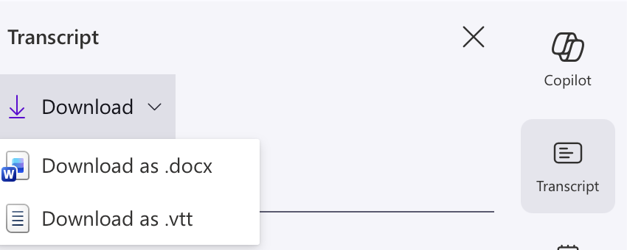

EV_Keywords_Executive
Purpose: Comma-separated keywords used to highlight executive-level discussion points.
Example value: exec; executive; management; leadership; steer
Notes: Since our solution differentiates between a regular and an executive meetings (different level of detail), you may define executive meeting file naming keywords, if different from the suggested above.

EV_Keywords_Regular
Purpose: Comma-separated keywords used for general action-agenda detection.
Example value: weekly; monthly; quarterly; annual; status; progress; review; committee
Notes: As above, applied to regular meetings.

EV_AI_Min_SpeakerLines
Purpose: Minimum number of transcript lines per speaker to be processed.
Example value: we indicated 300, which is enough for a 1-1,5-hour meeting. No need to change this EV.
Notes: Used to reduce noise (omit speakers who didn’t contribute to the conversations) and optimize AI credit usage. Don’t change this EV value, unless you want to apply this solution to a long (2+ hours meeting).

EV_AI_Max_SpeakerLines
Purpose: Maximum number of transcript lines per speaker to be processed.
Example value: 1200
Notes: Prevents overly long speaker blocks. As above.

EV_Max_File_Size_Bytes
Purpose: Maximum allowed transcript file size.
Example value: 5000000
Notes: Files larger than this will not be processed – to optimize AI usage and not to waste credits on excessively long meetings. Leave unchanged.

EV_Send_Email
Purpose: Controls whether email notifications are sent to all members from your list after processing. Otherwise, you may suffice with the MoM file having been uploaded in a dedicated SharePoint folder.
Example value: Yes / No – depending on if you need emails or not.
Notes: Optional feature toggle.

Operational Notes
- This solution assumes SharePoint structure already exists.
- It is intentionally configuration-driven and does not modify SharePoint structure.
- Do not rename or delete environment variables.
- Do not change folder paths without updating the corresponding environment variables.

What Happens After Environment Variables Are Set
Once all Environment Variables are configured and the flow is turned ON, the solution is operational.
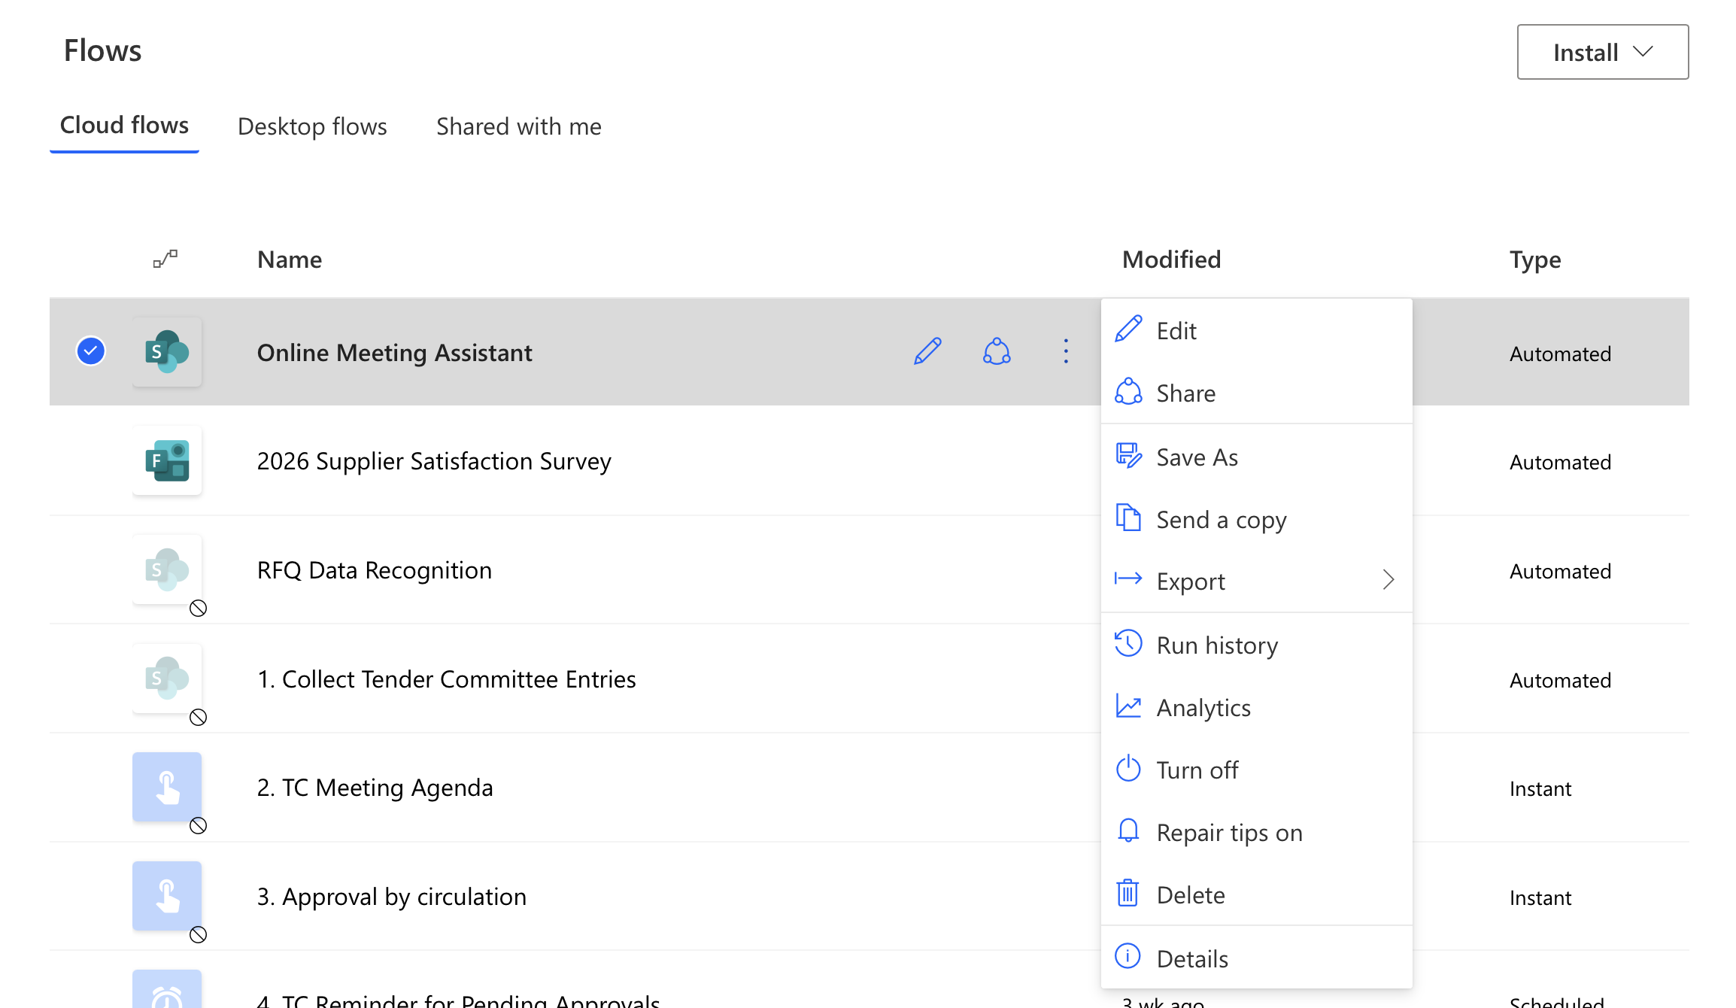
From this point onward:
- No further Power Automate configuration is required
- Users do not need to open Power Automate again
- The solution is operated entirely via SharePoint
The flow will execute when a transcript file is uploaded to the configured transcript folder.

How to Operate the Solution (End-User Instructions)

Step 1 — Upload a meeting transcript
- Open the SharePoint site specified in EV_SharePointSiteUrl
- Navigate to the transcript folder defined in:
  - EV_Transcript_FolderPath
  - Example:
Shared Documents / Meeting Transcripts
- Upload the meeting transcript file
  - Supported formats depend on EV_Transcript_Extension
  - Typical formats: .docx, .vtt
⚠️ Important:
- Upload one transcript per meeting
- Do not rename or move the file while processing is ongoing

Step 2 — Automatic processing (no user action required)
After upload, the flow automatically performs the following steps:
- Reads the transcript content
- Groups transcript text by speaker
- Applies speaker filtering rules:
  - Speakers with fewer lines than EV_AI_Min_SpeakerLines are excluded
  - Speakers exceeding EV_AI_Max_SpeakerLines are truncated
- Determines meeting type:
  - Executive or regular (based on filename keywords)
- Sends the filtered content to AI for processing
- Generates:
  - Meeting Minutes
  - Action Points / Decisions
- Saves the output file to:
  - EV_Minutes_FolderPath

Step 3 — Review generated meeting minutes
- Navigate to the minutes folder:
  - Example: Shared Documents / Meeting Minutes
- Open the generated document.
- Review and, if required, make manual edits
The output is a draft, intended for review before formal circulation.

Step 4 — Email distribution (optional)
If EV_Send_Email = Yes:
- The flow automatically emails the generated minutes to all members listed in the SharePoint Members List (EV_Members_ListId)
- Email recipients are taken from the Email column in that list
If EV_Send_Email = No:
- No emails are sent
- Distribution is handled manually using SharePoint links or other channels

Typical Operating Pattern
For each meeting:
- Upload transcript
- Wait for processing (usually a few minutes)
- Review generated minutes
- Optionally distribute

Video Guide
https://youtu.be/1W6FVhtgi4M

